Customer: Address:

Attn: Project:
Location: Number:
422285-002 TTC-01-KIT-IN-23-T Kitchenette 23 Sink
422285-001 TTC-01-KIT-IN-5-T Kitchen 5 Sink
Analysis Report

Labella Associates (1126)
300 State Street
Rochester, NY 14614-1098

Brockport CSD Lead In Water TTC Building
2211782
Schneider Laboratories Global, Inc
2512 W. Cary Street • Richmond, Virginia • 23220-5117 804-353-6778 • 800-785-LABS (5227) • Fax 804-359-1475
Order #: 422285
Matrix Drinking Water
Received 06/02/21
Reported 06/09/21

PO Number:

422285-005 TTC-01-HA-BY-27-DF Right Drinking Fountain
422285-004 TTC-01-HA-BY-27-DF Left Drinking Fountain
422285-003 TTC-01-KIT-IN-23-CT Kitchenette 23 Coffee
Derek Jackson

Reviewed By:
Sample ID | Cust. Sample ID | Location
Parameter |  | Method | Result | RL* | Units | Analysis Date | Analyst
Metals Analysis  Lead |  | EPA 200.9 Rev 2.2 | <5.00 | 5.00 | µg/L | 06/04/21 | JL
Metals Analysis  Lead |  | EPA 200.9 Rev 2.2 | <5.00 | 5.00 | µg/L | 06/04/21 | JL
Metals Analysis  Lead |  | EPA 200.9 Rev 2.2 | <10.0 | 10.0 | µg/L | 06/08/21 | JL
Metals Analysis  Lead |  | EPA 200.9 Rev 2.2 | <5.00 | 5.00 | µg/L | 06/04/21 | JL
Metals Analysis  Lead |  | EPA 200.9 Rev 2.2 | <5.00 | 5.00 | µg/L | 06/04/21 | JL
422285-06/09/21 04:59 PM

EPA Regulatory Limits  Parameter Reg. Limit  Lead 15.0 |  |  | Analyst
Unit
µg/L
State Certifications  Method Parameter |  | New York | Virginia
EPA 200.9 Rev 2.2 | Lead | ELAP Certified | VELAP Certified
State | Certificate Number
New York | ELAP 63556
Virginia | VELAP 11259

All internal QC parameters were met. Unusual sample conditions, if any, are described. Surrogate Spike results designated with "D" indicate that the analyte was diluted out. "MI" indicates matrix interference. Concentration and *Reporting Limit (RL) based on areas provided by client. Values are reported to three significant figures. Solid PPM = mg/kg | PPB = µg/kg and Water PPM = mg/L | PPB = µg/L. The test results reported relate only to the samples submitted.
Page 1 of 1

SCHNEIDER LABORATORIES GLOBAL, INC.

2512 West Cary Street, Richmond, Virginia 23220-5117 804-353-6778 • 800-785-LABS (5227) • Fax 804-359-1475
www.slabinc.com e-mail: info@slabinc.com

fghraizi

S 5
422285

V:\422\422285
6/2/2021 9:45:54 AM -

Submitting Co.

LaBella Associates, D.P.C.

300 State Street
Lab WO#

Acct#

/*State of

1126
' ", ''

·..
Phone

Fax/ Email
ttcert..
'-- Il=P S 1.u7,_1c::,5,'.<EZ90.'35679865L-
(607) 591-7516

cstamp@labellapc.com

Rochester, New York 14614
C llet:tion NY , •·
,,, ,.,., 'Re'quired

Project Name:
Brockport CSD Lead in Water Testing

Special Instructions [include requests for special reporting or data packages]

Project Location: TTC Building
See attached spreadsheet

Project Number:

2211782

PO Number:
,. ,Turn Afound Ti e ''.
D2 hours* Osame day•

All samples on form should be of SAME matrix fVPe, Use additional forms as needed.

0 PCM (NIOSH 7400}

0 PLM (EPA 600/R-93/116)

[El Lead

D 1 business day*
□Air
0 Solid
0 TEM (AHERA)
0 PLM (EPA Point Count)
0 RCRA Metals

D 2 business day*
D Aqueous
D Waste
0 TEM (EPA Level II) 0 PLM (Qualitative only)
□ ­

D 3 business days•
[Rl 5 business days*
D Bulk D Wastewater
D Hi-Vol Filter (PM10) [Rl Water,Drinking
0 0 NYELAP 198.1/.4/.6 □
Nlis·cellimeous Tests' .,,. D CAELAP (EPA Interim)

0 Full TCLP (10d} 0 Hi-Vol Filter (TSP) 0 Compliance
0 Weekend* 0 Oil O Wipe
- not available for all tests D Paint D Wipe, Composite
0 Total Dust (NIOSH 0500) 0 TEM (Chatfield) 0 TCLP / Lead
0 Resp, Dust (NIOSH 0600) 0 0 TCLP / RCRA Metals
0 Silica - FTIR (NIOSH 7602) FOR ASBESTOS AIR: 0 TCLP / Full (w/ organics)

Schedule rush organics, multi- D Sludge □
advance. □
metals & weekend tests in
Dsoil
0 Silica -XRD (NIOSH 7500) TYPE OF RESPIRATOR

0 Mold Direct Exam USED:

'

Others
□

Sample#
Date ··
Sampled**
Time Samoled**
Sample Identification
/Emolovee SSN Blda. Material, Tvoe¹)
Wiped Area /ft²)
pH/ Temo •
Time'
Start Stoo
Flow Rate" Start Stop
Total⁴ Air

/'1J
I

11

/
(
f
I

1Tvoe: A=area B=blank P=oersonal E=excursion 2Be11innin11/End of Sample Period 3Pumo Calibration in Liters/Minute 4Volume in Liters [time in min • flow in Umin]
Sampled by Relinquished to lab by Samole Disposal
If samp/8s over req. weight
(Refer to Fee Schedule)
NAME Cory Stamp NAME Cory Stamp DReturn to Sender (Shipping fees)
DDisposal by lab ($50 fee)

SIGNATURE SIGNATURE
,-

Shipping Methods

DATE/TIME
2021

DATE/TIME
0 FX 0 UPS 0 USM
0 HD 0 DB

D Sample return requested D Ambient temo D Ice Cl D R D S□X
D Receive a physical copy of report. WB:

- 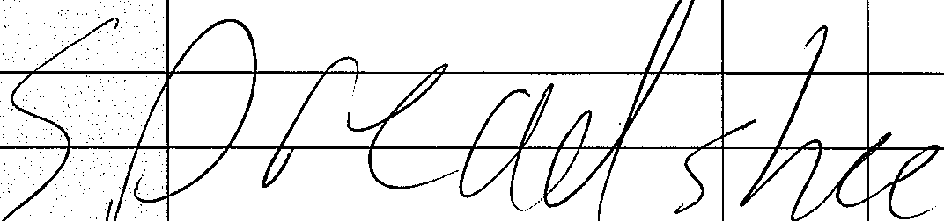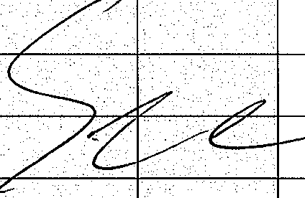Temperature taken with JR Gun A. .. Required. Chain-of-Custody documentation continued internally within lab.Terms and conditions page 2.

Tech Center
New Identification Code | Description | Time Sampled | Comments
TTC-01-KIT-I N-5-T | Kitchen 5 Sink | 524
TTC-01-KIT-IN-23-T | Kitchenette 23 Sink | 525
TTC-01-KIT-IN-23-CT | Kitchenette 23 Coffee Line | 525
TTC-01-HA-BY-27-DFl | Left Drinking Fountain by Men's 27 | 527
TTC-01-HA-BY-27-DF2 | Right Drinking Fountain by Men's 27 | 527

