Customer: Address:

Attn: Project:
Location: Number:
422286-002 ADM-01-KIT-IN-8-CT Kitchen 8 Coffee Line
422286-001 ADM-01-KIT-IN-8-T Kitchen 8 Sink
Analysis Report

Labella Associates (1126)
300 State Street
Rochester, NY 14614-1098

Brockport CSD Lead In Water Administration Building 2211782
Schneider Laboratories Global, Inc

2512 W. Cary Street • Richmond, Virginia • 23220-5117 804-353-6778 • 800-785-LABS (5227) • Fax 804-359-1475
Order #: 422286
Matrix Drinking Water
Received 06/02/21
Reported 06/09/21

PO Number:

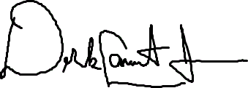
422286-005 ADM-01-EXT-BY-22- Hose Bib by 22
422286-004 ADM-01-HA-BY-17-B Bottle Filler by 17
422286-003 ADM-01-KIT-IN-8-CP Kitchen Coffee Pot
Derek Jackson

Reviewed By:
Sample ID | Cust. Sample ID | Location
Parameter |  | Method | Result | RL* | Units | Analysis Date | Analyst
Metals Analysis  Lead |  | EPA 200.9 Rev 2.2 | <5.00 | 5.00 | µg/L | 06/04/21 | JL
Metals Analysis  Lead |  | EPA 200.9 Rev 2.2 | <10.0 | 10.0 | µg/L | 06/08/21 | JL
Metals Analysis  Lead |  | EPA 200.9 Rev 2.2 | <5.00 | 5.00 | µg/L | 06/04/21 | JL
Metals Analysis  Lead |  | EPA 200.9 Rev 2.2 | <5.00 | 5.00 | µg/L | 06/04/21 | JL
Metals Analysis  Lead |  | EPA 200.9 Rev 2.2 | 16.6 | 5.00 | µg/L | 06/04/21 | JL
422286-06/09/21 04:55 PM

EPA Regulatory Limits  Parameter Reg. Limit  Lead 15.0 |  |  | Analyst
Unit
µg/L
State Certifications  Method Parameter |  | New York | Virginia
EPA 200.9 Rev 2.2 | Lead | ELAP Certified | VELAP Certified
State | Certificate Number
New York | ELAP 63556
Virginia | VELAP 11259

All internal QC parameters were met. Unusual sample conditions, if any, are described. Surrogate Spike results designated with "D" indicate that the analyte was diluted out. "MI" indicates matrix interference. Concentration and *Reporting Limit (RL) based on areas provided by client. Values are reported to three significant figures. Solid PPM = mg/kg | PPB = µg/kg and Water PPM = mg/L | PPB = µg/L. The test results reported relate only to the samples submitted.
Page 1 of 1

SCHNEIDER LABORATORIES GLOBAL, INC.

2512 West Cary Street, Richmond, Virginia 23220-5117 804-353-6778 • 800-785-LABS (5227) • Fax 804-359-1475
www.slabinc.com e-mail: info@slabinc.com
-
S 5
422286
V:\422\422286

I fghraizi 6/2/2021 9:45:54 AM
----- ----------------- -- ---------I------" u.es 17153E700356.Z98B56 -

Submitting Co.
LaBella Associates, D.P.C.

300 State Street
Lab WO#

Acct#

""J;tat ot

1126
·· ·.
Phone

Fax/ Email
*,*Cert·
(607) 591-7516

cstamp@labellapc.com

Rochester, New York 14614
Colle(?tiori t.lY >
, Required

Project Name:

Brockport CSD Lead in Water Testing

Special Instructions [include requests for special reporting or data packages)

Project Location: Administration Building

See attached spreadsheet

Project Number:
2211782

PO Number:
. . ,. .. . •.... .

Tum Arouild:Time
D2 hours•

All samples on form should be of SAME
.• ... . . ·.· .. > . ': ,·. ·. ...,,. : .'.
Asbestos Air/ Fiber Counts . Asbestos Bulk / Asb•ID ' ' : Metals Tot I ,Coric:. .

Osameday*
matrix type. Use additional forms as needed.
0 PCM (NIOSH 7400)
0 PLM (EPA 600IR-93/116)
[El Lead

D 1 business day•
□Air
0 Solid
0 TEM (AHERA)
0 PLM (EPA Point Count)
0 RCRA Metals

D 2 business day•
D Aqueous
D Waste
0 TEM (EPA Level II) 0 PLM (Qualitative only)
□-------

D 3 business days*
[El 5 business days*
D Bulk D Wastewater
0 Hi-Vol Filter (PM10) (El Water,Drinking
□=-========---1□NYELAP 198,1/.4/.6
1---·M=i=sc=e=Ua=n=e=o=us·•T =s=ts ·· ---10 CAELAP (EPA Interim)

>
:-·•. Metals Extract ·

0 Full TCLP (10d)
□
□Weekend*
- not available for all tests
D Hi-Vol Filter (TSP) D Compliance
□Oil O Wipe
D Paint D Wipe, Composite
0 Total Dust (NIOSH 0500) 0 TEM (Chatfield) 0 TCLP / Lead
0 Resp. Dust (NIOSH 0600) □========= 1□TCLP / RCRA Metals
0 Silica - FTIR (NIOSH 7602) FOR ASBESTOS AIR: 0 TCLP / Full (w/ organics)

Schedule rush organics, multi• D Sludge □
0 Silica - XRD (NIOSH 7500) TYPE OF RESPIRATOR
: ·.
·Others.·. . '·.

metals & weekend tests In
advance.
Dsoil □
0 Mold Direct Exam USED: □

Samole#
Date SamDled**

Time
SamDledt•
Sample Identification (Employee, SSN Bldq, Material, Type¹)
Wiped Area (ft2l
pH / Temp*
Time"
Start Stoo
Flow Rate³
Start Stoo
Total⁴ Air

/}

.
I I
I

1Tvoe: A=area B=blank P=oersonal E=excursion 2Beainnina/End of Samole Period 3Pumo Calibration in Liters/Minute "volume in Liters [time in min * flow in L/min]

Sampled by

NAME C _ry_S_t ar7'::ryv,;----
SIGNATURE ---= ::.=-ftl dl-'-r_· _
Relinquished to lab by

NAME ---- -C_o ry_S_t_a_ _.--­
SIGNATURE ---, ,,,,..--,fr--"¥--r ---
Samr.le Disposal
If samp es over req. weight (Refer to Fee Schedule)
DReturn to Sender (Shipping fees)
DDisposal by lab ($50 fee)
Shipping Methods

DATE/TIME
/it t2)dl _0_2 1 _
DATE/TIME f
f2_0_2_1
D FX D UPS D USM
D HD D DB

D Samole return requested n Ambient temo n Ice Cl D R D SD X
D Receive a physical copy of report.
WB:

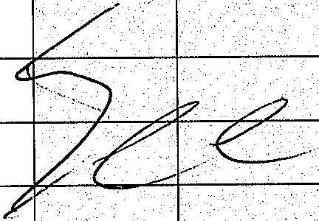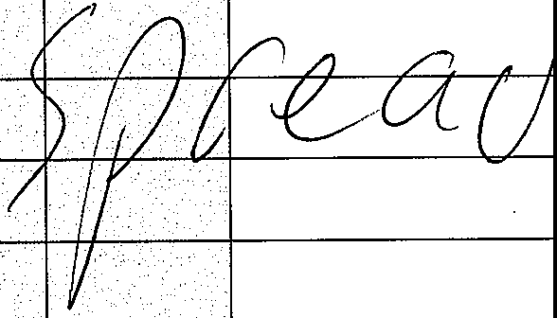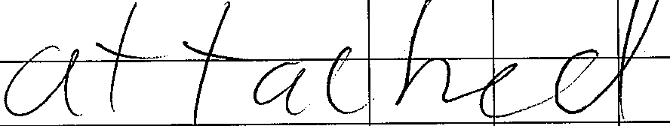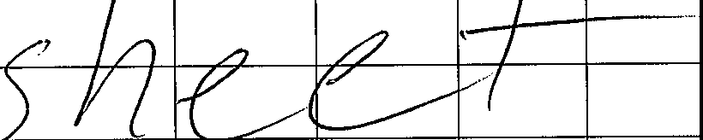* Temperature taken with IR Gun A "Required. Chain-of-Custody documentation continued internally within lab.Terms and conditions page 2.

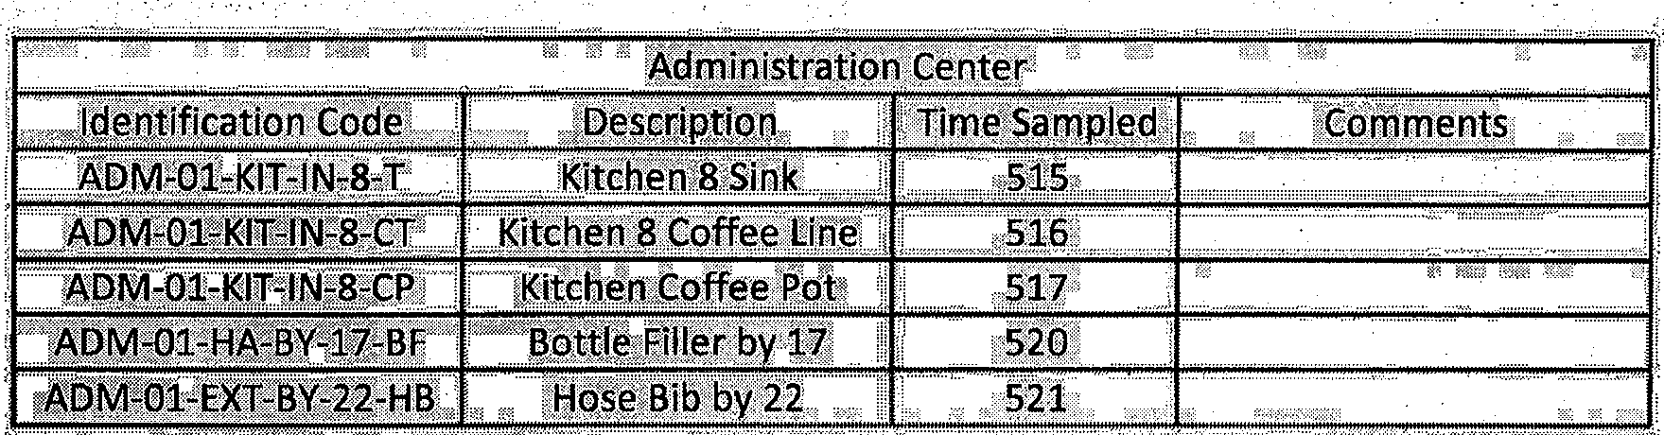

t ' •

