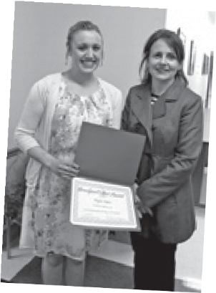
Brockport’s Best
An Official Publication of the Brockport Central School District, Brockport,
New York 14420-2296

NEWSLETTER
During the April 22 Board of Education meeting, high school senior Taylor Mateo was thanked for giving back to Make-A-Wish Foundation after her wish was granted last year. This year, she asked that the student-led fashion show be held again – this time to raise funds for the Make-A-Wish Foundation. The Fashion Show raised more than $2,600. A special thanks to seniors Isabella Ekeze, Victoria Falco, Jessica Emmerson and advisor Dwenna Nelson, along with all the participants, for producing the show.

Board of Education
Lisa Ireland, President
Term Expires June 30, 2018
Ray Gabriel, Vice President
Term Expires June 30, 2015
Terry Ann Carbone, Trustee
Term Expires June 30, 2019
Michael Guerrieri, Trustee
Term Expires June 30, 2018
Gerald C. Maar, Trustee
Term Expires June 30, 2016
Kathleen Robertson, Trustee
Term Expires June 30, 2019
Gary Zimmer, Trustee
Term Expires June 30, 2017
Lesli C. Myers, Ed.D., Superintendent
Melissa Fingar, Esq., Assistant Superintendent for Human Resources
Darrin Winkley, Assistant Superintendent for Business
Lynn Carragher, Assistant to the Superintendent for Inclusive Education and Instruction
Susan Hasenauer-Curtis, Assistant to the Superintendent for Elementary Instruction
Rachel Kluth, Assistant to the Superintendent for Secondary Instruction
Jill Reichhart, Director of Finance Debbie Moyer, Editor
Lisa Mott, Graphic Designer
During the May 20 Board of
Education meeting, Nurse’s Aide Jenna Menear was honored for her quick actions during a medical emergency after a student experienced a seizure. Student, Nicky Cappadonia and his family attended the meeting to show their appreciation.
On June 3, High School Music Teacher Liz Banner was honored for receiving the Rochester Philharmonic Orchestra’s Outstanding Choral Teaching Award
of the Year. The award recognizes outstanding music educators and enhances the understanding and communication between the professional musicians of the RPO and the music educators of the Rochester area. Mrs. Banner was honored at an awards ceremony and special RPO performance on May 22.
High School Librarian Kathleen Jaccarino and Library Media Assistants Jane Agte and Pauline Pratt were also honored on June 3 for running an outstanding high school library. The High School Library was recently awarded Library of the Year by the Rochester Regional Library Council! The judges noted the number of thoughtful nominations and that library staff was mentioned by name. They all agreed that, “The library is loved by the students as well as the teaching staff.”
During the June 17 Board meeting, student athletes and coaches were honored for their accomplishments (see Athletics page XV). Also during the meeting, Board President Mike Andriatch surprised Vice President April VanGelder with a Brockport’s
Best for her dedication to improving our District. He said “In her first four years on the Board, she chaired the Monroe County School Boards Association’s Information Exchange Committee, sat
To view all Brockport’s Best recipients for the 2013-2014 school year or to nominate someone for the award,
visit www.bcs1.org/boe.
on the MCSBA’s Steering Committee, has been an active voice within the District on numerous instructional issues, and, most
famously, has been a fiscal watchdog on many projects…” Trustee Lisa Ireland then surprised President Andriatch with a Brockport’s Best, making special mention of his countless contributions and how instrumental he has been in increasing Brockport Central School’s partnership with The College at Brockport.
Summer 2014 | Brockport central School DiStrict
16

